**Web Client Setting Guide**

1. **Add the Trust WebSite in Java Setting (here use IE9 32bit for example)**

A. Open readerSetting.html in IE，and copy the address-link ：

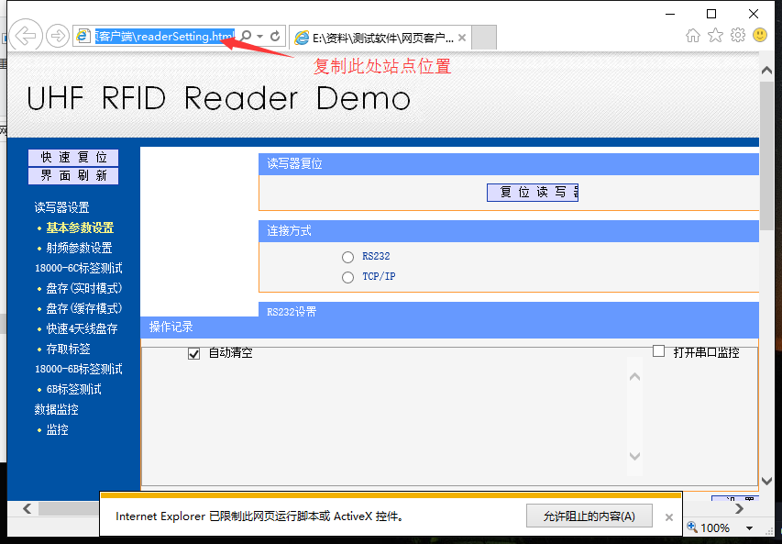

B.To ensure that the windows system has been installed the latest version of Java and verify the success of the installation, as shown below:



Java Download the installation URL：[www.java.com](http://www.java.com)

C .Open the java settings in the control panel, enter the security page and click Edit Site List:

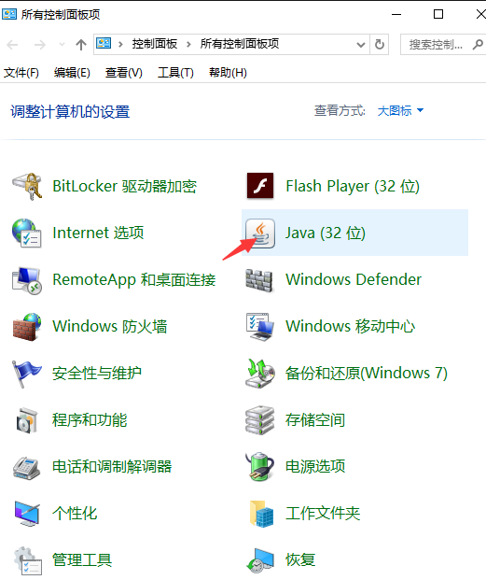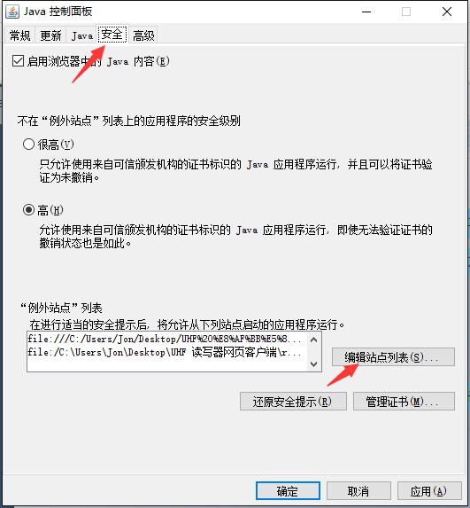

D. Click Add, and paste the site address copied in the first step here, click OK:

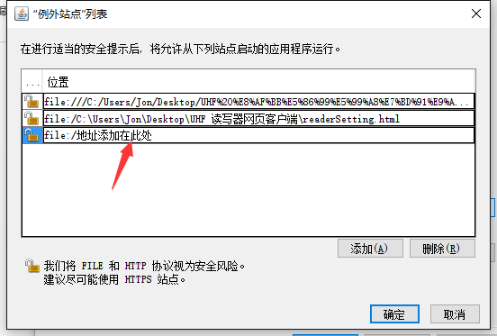

Note: the paste address Start with a “file: / ” , if not,must be manually entered into.

**2. Connect the Reader**

A. Open the browser again by admin and copy the site address to the addressbar .



B.When pop up all tips,pls all choose to allow, for example:  
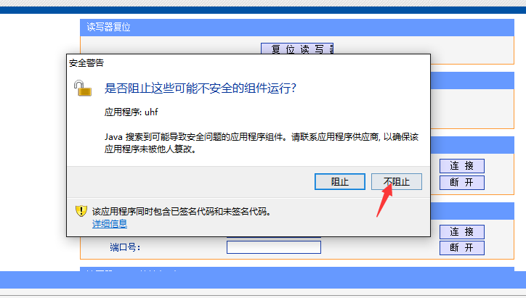

C.Select the appropriate serial port for reader (if use TCP / IP communication, fill in the correct IP and port number):

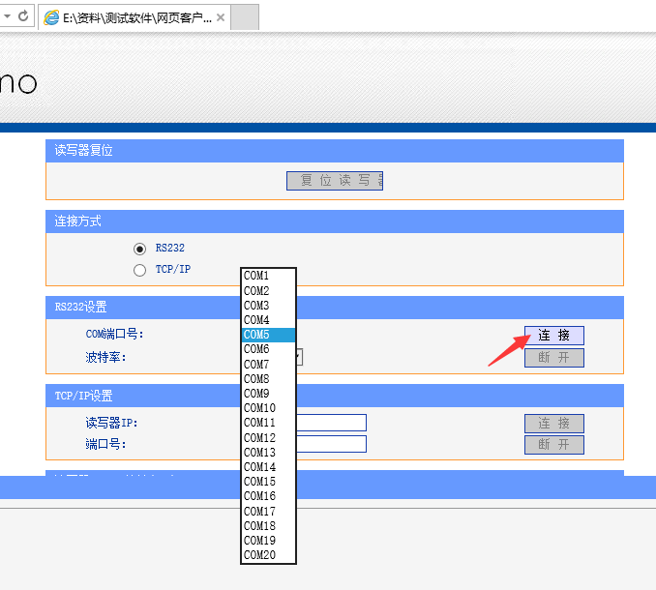

D.After the connection is successful, the page wil pops up a successful prompt if click the read the firmware version button.

